Full Title of the Paper

Author1 Name
University, Country

Author2 Name
University, Country

Author 1 is an Associate Professor of Linguistics in the International Languages College of XXX University, City, Country, where she specializes in … 75 words or less for one individual’s bio-statement, may include an email address and an ORCHID: https://orcid.org/0000-0000-0000-0000

Author 2 is a graduate student … (60 words or less for each author if there are two or more authors/co-authors, may include an email address and an ORCHID ID).

Abstract
What is the problem? Outline the objective, problem statement, research questions and hypotheses. What has been done? Explain your method. What did you discover? Summarize the key findings and conclusions. What do the findings mean? Summarize the discussion and recommendations. Do not argue here, nor should you discuss the setting. What is the problem? Outline the objective, problem statement, research questions and hypotheses. What has been done? Explain your method. What did you discover? Summarize the key findings and conclusions. What do the findings mean? Summarize the discussion and recommendations. What is the problem? Outline the objective, problem statement, research questions and hypotheses. What has been done? Explain your method. What did you discover? Summarize the key findings and conclusions. What do the findings mean? Summarize the discussion and recommendations. What is the problem? Outline the objective, problem statement, research questions and hypotheses. What has been done? Explain your method. What did you discover? Summarize the key findings and conclusions. What do the findings mean? Summarize the discussion and recommendations. What is the problem? Outline the objective, problem statement, research questions and hypotheses. What has been done? Explain your method. What did you discover? Summarize the key findings and conclusions. What do the findings mean? Summarize the discussion and recommendations. Do not argue here nor should you discuss the setting. (MAXIMUM 250 WORDS) (Abstract and Biographicals and Keywords are indented 1 centimeter left and right, and aligned both left and right sides)

Keywords: medical, bio, innovation, engineering (4-7 WORDS OR PHRASES, comma separated, lower-case except proper nouns)

Heading Level 1 (Major Section) Introduction to the Study (Title Case, Bold, Centered, Single Blank Line above)
All text and headings in the paper should be Times New Roman, 12 point, except for the paper title and (perhaps?) tables text (only if necessary). All paragraphs are indented 0.75 centimeters, including the first paragraph following a section header. All paragraphs are both left- and right-aligned. Line spacing at 1.5 except in Abstract/Keywords and Bio (single spaced), perhaps in Tables (as needed). No Footnotes, avoid Endnotes.
This research aims to gain insight into the relationship between smartphones and students’ attention in classrooms. This chapter further discusses the research method, the sampling method and the data analysis procedure. (Align standard text both left and right)
Heading Level 2 (Sub-section) Setting Under Investigation (Title Case, Bold, Left Align only, No Blank Lines Above)
In addition to an extensive literature review, 40 interviews were conducted for this study. The goal of conducting interviews was to find out how students looked at the use of smartphones in the classroom.
Heading 3 (sub-sub-section). Population of the study. (Sentence case, bold, indented, begins the paragraph, no blank line above) A non-probability sample was used to gather participants for this research. The driving factors behind this decision were cost and convenience.
Heading 4 (lowest level subsection). Student population. (Sentence case, italics, indented, begins the paragraph, no blank line above) Students who participated in this study were recruited through posts on the school’s Facebook page. As an incentive, students who participated were granted an exemption from writing an essay.
Note that all paragraphs are indented 0.75 centimeters, including the first paragraph following a section header. All paragraphs are both left- and right-aligned.
Bullets (left aligned only, do not right align, indent 1cm + 0.5 for additional lines)
- Asdf
- Asdf
- Asdf
Enumerations (left aligned only, not right align, indent 0.75cm + 0.75 for additional)
1. Asdf
2. Asdf
3. Asdf
The next line of text begins immediately after your bullets or enumerations. If a new paragraph, indent. If a continuation of the preceding paragraph, do not indent.
Long quotes (more than 35 words, or where the text extends across more than two lines of the formatted page) should be formatted with 1.5 centimeter indent on left and right. No quotation “marks” for long quotes. (Left alignment only, do not right align)
Do not double-space lines between paragraphs, before or after long quotes, or between sections in your article.
Single space (spacebar) following each sentence. Including end of paragraph.
If you need a particular font (e.g., are including text from a corpus or computer database, etc.) please consult the editor for style.
In-text citations follow APA style. (op cit and Ibid are not used). Footnotes are strongly discouraged. Use Endnotes if your message requires an extended parenthetical remark, but do not use the Microsoft Word® automation, manually indicate an Endnote with superscript in-text, and present your note in a section marked Endnotes before the References. The section title Endnotes gets Level 1 Header format, text within Endnotes is hanging-indent 12-point Times Roman, following the Enumerations style above.
Single blank line between end of text and title of a table (modify for appearances, e.g., start a new page). DO NOT BREAK TABLES ACROSS PAGES UNLESS ABSOLUTELY NECESSARY. (better alignment of column heads preferred)

TABLE 1. (Note CAPITALIZATION, Bold)
Graduation Rates (Title Case, Bold)
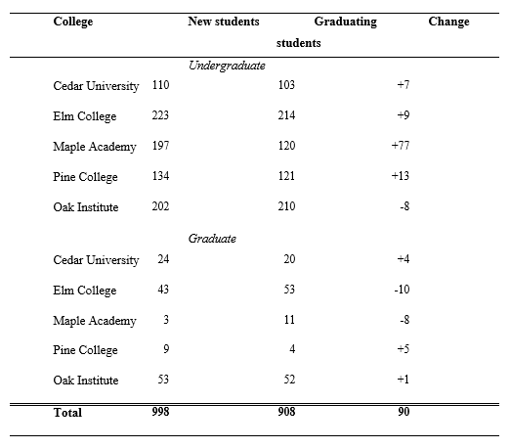
Single blank line (1.5 spacing) between bottom of table or figure and next line of ordinary text (modify for appearance, e.g., you may need to start a fresh page). If text follows on a new page, do not leave the top line blank.
(you may insert your table as an image file if it is easily readable. Please use our standard font (Times Roman), you may use single-line spacing or 1.5 spacing between lines in tables, you may use text size 9-12 in tables, and you insert a table on the page sideways if you require more width than 9 point side will allow.)
No extra spacing between end of regular text and beginning of a figure. Note that a figure’s title is below the image. Place your tables and figures in the text at the place where they should appear (approximately). Figures need not extend across the page, re-size as needed for visibility. If not full-width, center on the page. Avoid lines around the figure if possible.
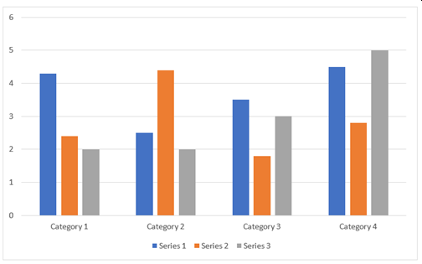
FIGURE 1. Success rates. (note CAPITALIZATION, Bold, Sentence Case)

And this is the next paragraph….

References Heading Level 1 (Major Section)
AuthorLastName, FirstInitial., & Author LastName, FirstInitial. (Year). Title of article. Title of Journal, Volume(Issue), Page Number(s). https://doi.org/number or website URL for journals that offer these.
Do not list non-official sources (academia.edu, researchgate.net, SSRN, faculty or student web-postings, etc.). (left aligned only)
AuthorLastName, FirstInitial., & Author LastName, FirstInitial. (Year). Title of article. Title of Journal, Volume(Issue), Page Number(s). https://doi.org/number
AuthorLastName, FirstInitial., & Author LastName, FirstInitial. (Year). Title of article. Title of Journal, Volume(Issue), Page Number(s). https://doi.org/number
AuthorLastName, FirstInitial., & Author LastName, FirstInitial. (Year). Title of article. Title of Journal, Volume(Issue), Page Number(s). https://doi.org/number
AuthorLastName, FirstInitial., & Author LastName, FirstInitial. (Year). Title of article. Title of Journal, Volume(Issue), Page Number(s). https://doi.org/number

Appendix A Heading Level 1 (Major Section)

(indentation as seems appropriate, line spacing as seems appropriate.)
You may place your representation of a survey, etc within a box (lines on 4 sides) if you wish,

